ASSIGNMENT 3

|  |  |
| --- | --- |
| Assignment Date | 11 October 2022 |
| Student Name | DINESH KUMAR K |
| Student Roll Number | 1921402 |
| Maximum Marks | 2 Marks |

# Question 1:

Create a bucket in IBM object storage.

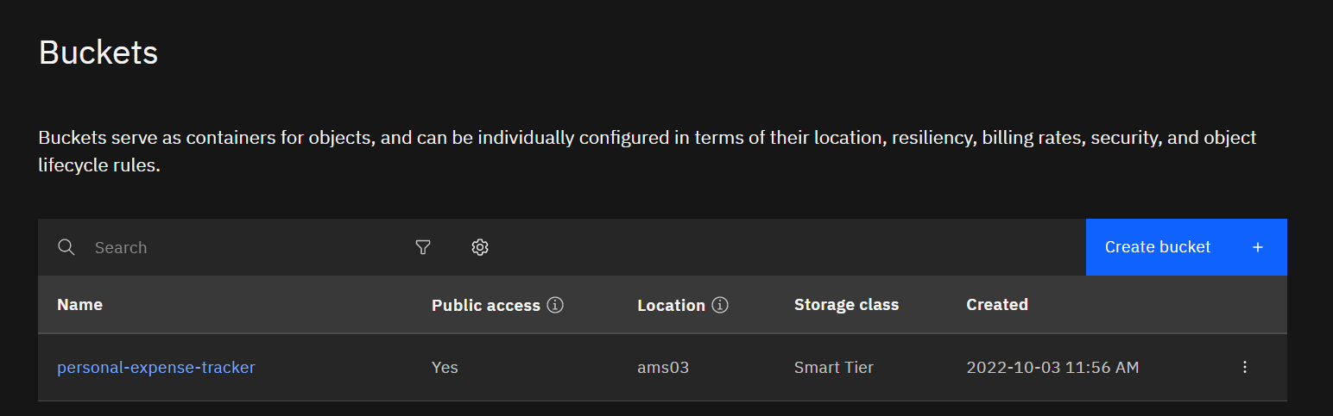

# Question 2:

Upload any 5 images to IBMobject storageandmakeitpublic. Write HTML code to displaying all the 5 images

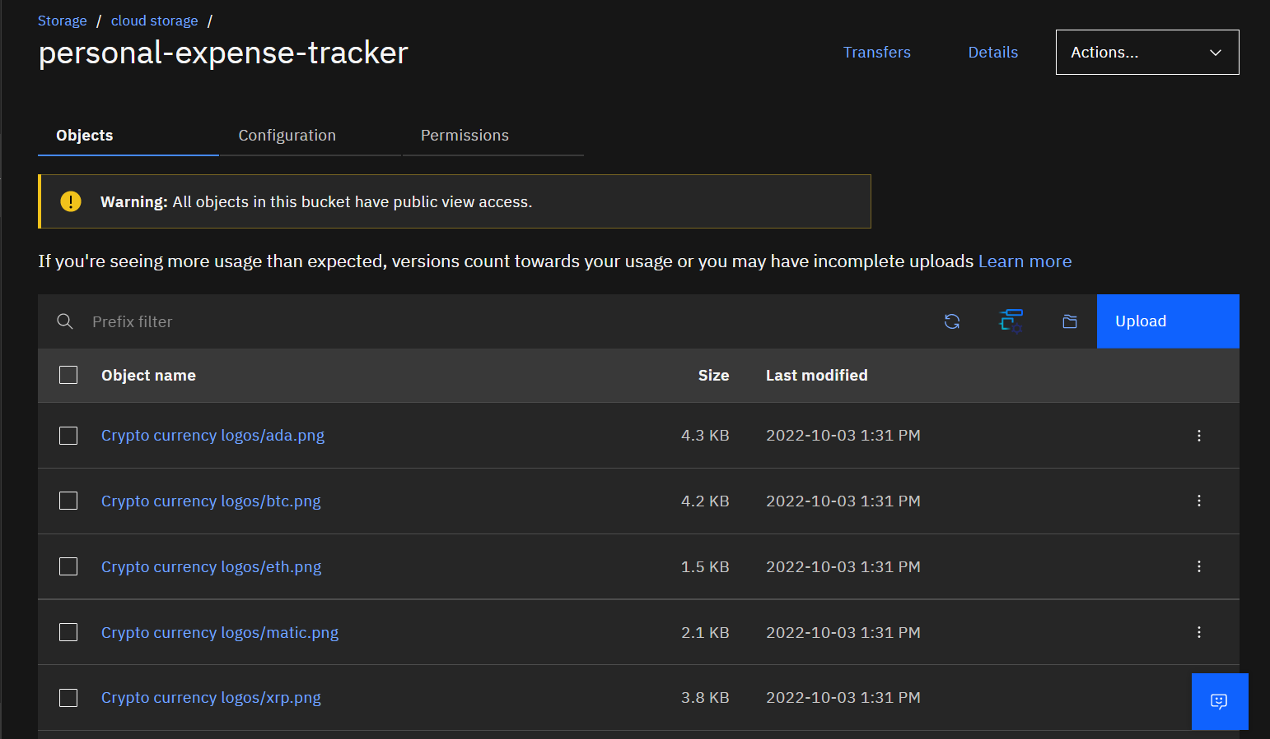

HTML code for displaying images in cloud

<!DOCTYPE html>

<html lang="en" dir="ltr">

<head>

<meta charset="utf-8">

<title>Crypto currencies</title>

</head>

<body>

<h1>Popular Cryptocurrencies</<h1>

<h2>1 Bitcoin BTC </h2>

<img

src="https://personal-expense-tracker.s3.ams03.cloud-object-storage.appdoma in. cloud/Crypto%20currency%20 logos/btc.png" alt="Bitcoin">

<h2>2 Ethereum ETH</h2>

<img

src="https://personal-expense-tracker.s3.ams03.cloud-object-storage.appdoma in. cloud/Crypto%20currency%20 logos/eth.png" alt="Ethereum">

<h2>3 Polygon MATIC</h2>

<img

src="https://personal-expense-tracker.s3.ams03.cloud-object-storage.appdoma in. cloud/Crypto%20currency%20 logos/matic.png" alt="Polygon">

<h2>4 Ripple XRP</h2>

<img

src="https://personal-expense-tracker.s3.ams03.cloud-object-storage.appdoma in. cloud/Crypto%20currency%20 logos/xrp.png" alt="XRP">

<h2>5 Cardano ADA</h2>

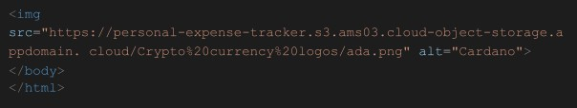

HTML Output for displaying images from IBM cloud storage:

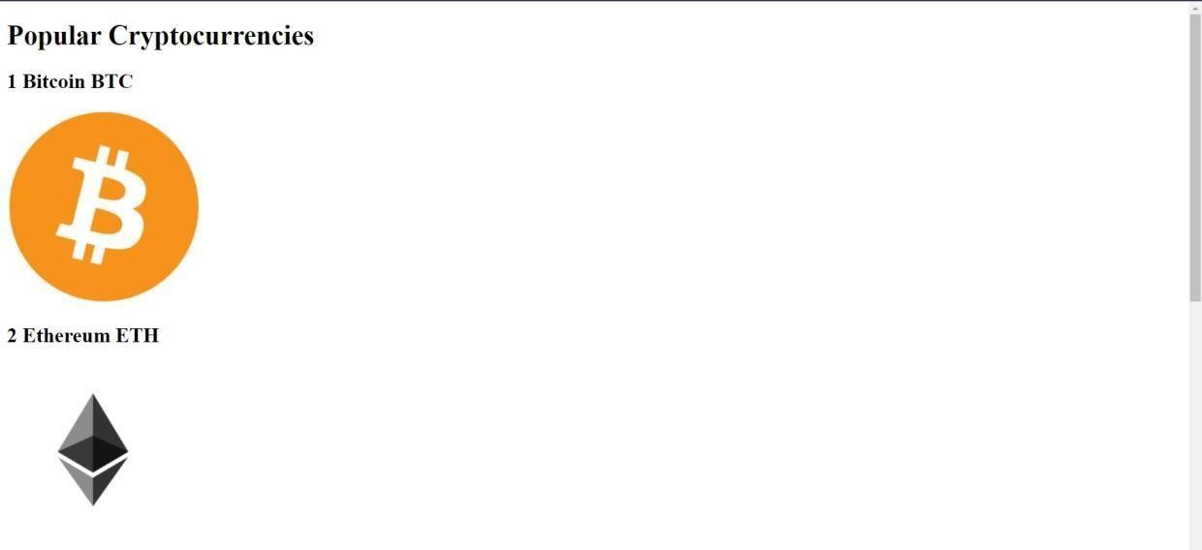

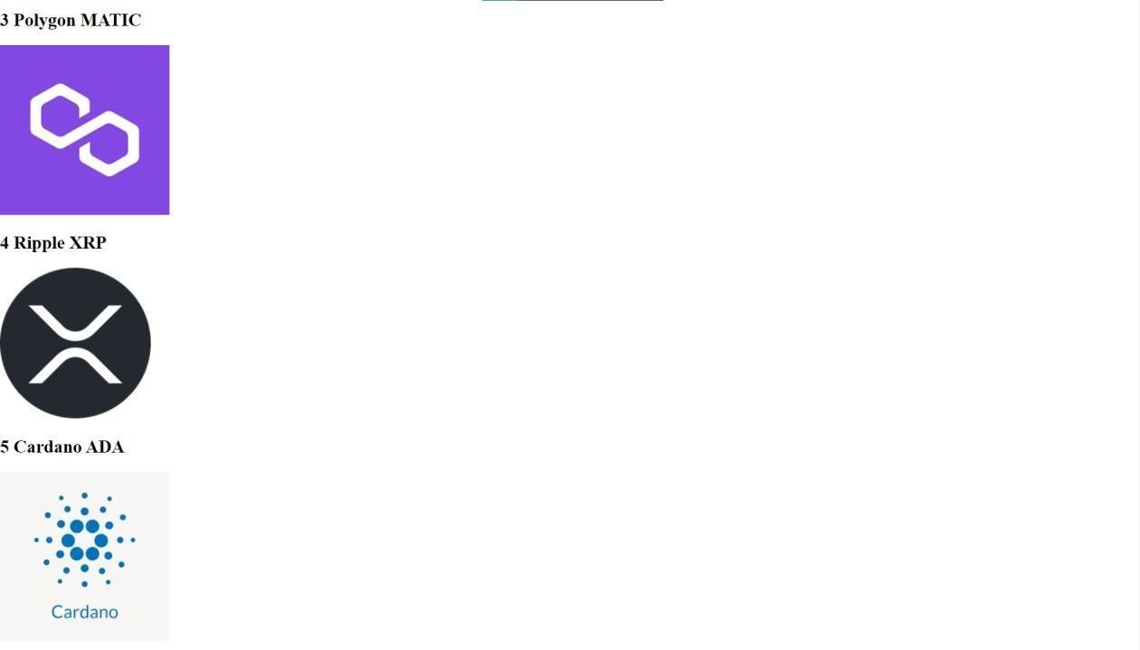

# Question 3:

Upload a CSS page to the object storage andusethe same pagein your HTML code.

HTML code with CSS ﬁle present in IBM cloud storage:

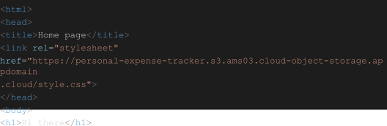

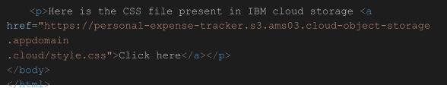

HTML code output:

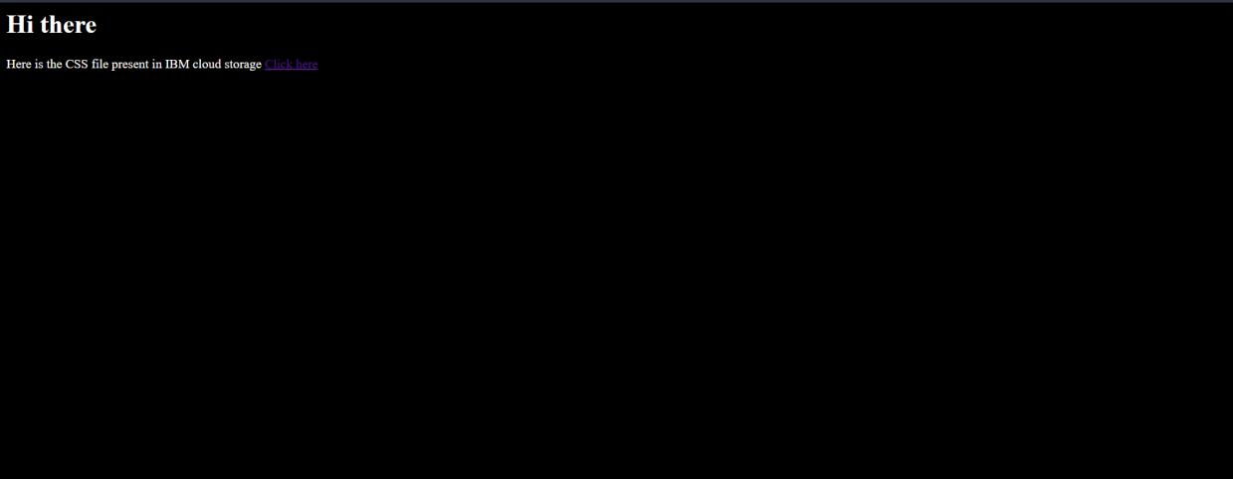

CSS ﬁle in Cloud object storage

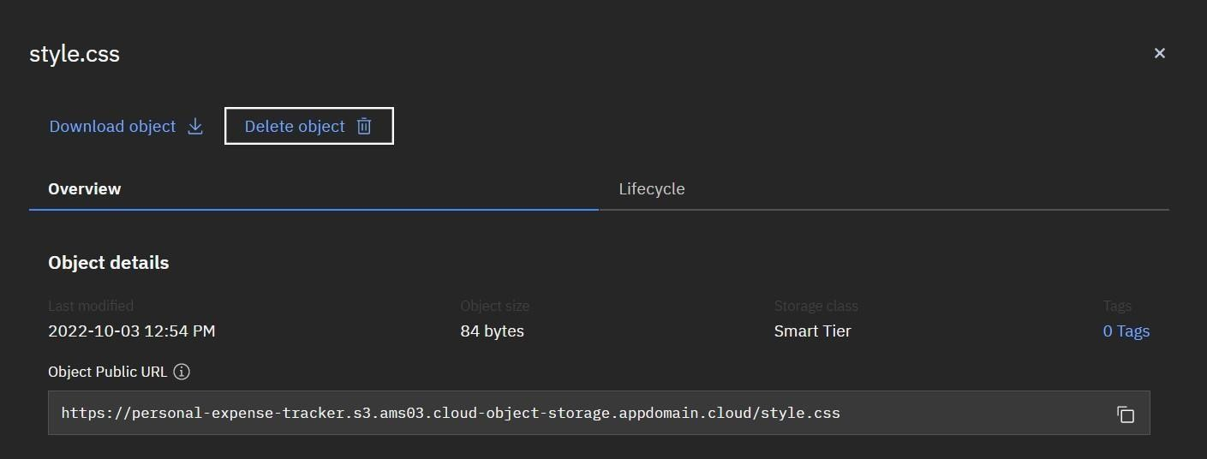

# Question 4:

Design a chatbot using IBM Watson assistant for hospital. Ex: User comes with query to know the branches for that hospital in your city. Submit the web URL of that chat bot as a assignment.

# Web URL of chat box:

[https:*/* web-chat.global.assistant.watson.appdomain.cloud/preview.html?ba](https://web-chat.global.assistant.watson.appdomain.cloud/preview.html?backgroundImageURL=https%3A%2F%2Fjp-tok.assistant.watson.cloud.ibm.com%2Fpublic%2Fimages%2Fupx-f3a1f015-5572-4204-96b6-7c25f885ddc6%3A%3A156bcb72-665e-46b3-872e-a17217657433&integrationID=d2b53d34-6e0e-4d81-b157-ae1023cd641a&region=jp-tok&serviceInstanceID=f3a1f015-5572-4204-96b6-7c25f885ddc6) [ckgroundImageURL=https%3A%2F%2Fjp-tok.assistant.watson.cloud.ibm.co](https://web-chat.global.assistant.watson.appdomain.cloud/preview.html?backgroundImageURL=https%3A%2F%2Fjp-tok.assistant.watson.cloud.ibm.com%2Fpublic%2Fimages%2Fupx-f3a1f015-5572-4204-96b6-7c25f885ddc6%3A%3A156bcb72-665e-46b3-872e-a17217657433&integrationID=d2b53d34-6e0e-4d81-b157-ae1023cd641a&region=jp-tok&serviceInstanceID=f3a1f015-5572-4204-96b6-7c25f885ddc6) [m%2Fpublic%2Fimages%2Fupx-f3a1f015-5572-4204-96b6-7c25f885ddc6](https://web-chat.global.assistant.watson.appdomain.cloud/preview.html?backgroundImageURL=https%3A%2F%2Fjp-tok.assistant.watson.cloud.ibm.com%2Fpublic%2Fimages%2Fupx-f3a1f015-5572-4204-96b6-7c25f885ddc6%3A%3A156bcb72-665e-46b3-872e-a17217657433&integrationID=d2b53d34-6e0e-4d81-b157-ae1023cd641a&region=jp-tok&serviceInstanceID=f3a1f015-5572-4204-96b6-7c25f885ddc6)

[%3A%3A156bcb72-665e-46b3-872e-a17217657433&integrationID=d2b5](https://web-chat.global.assistant.watson.appdomain.cloud/preview.html?backgroundImageURL=https%3A%2F%2Fjp-tok.assistant.watson.cloud.ibm.com%2Fpublic%2Fimages%2Fupx-f3a1f015-5572-4204-96b6-7c25f885ddc6%3A%3A156bcb72-665e-46b3-872e-a17217657433&integrationID=d2b53d34-6e0e-4d81-b157-ae1023cd641a&region=jp-tok&serviceInstanceID=f3a1f015-5572-4204-96b6-7c25f885ddc6) [3d34-6e0e-4d81-b157-ae1023cd641a&region=jp-tok&serviceInstanceID=f](https://web-chat.global.assistant.watson.appdomain.cloud/preview.html?backgroundImageURL=https%3A%2F%2Fjp-tok.assistant.watson.cloud.ibm.com%2Fpublic%2Fimages%2Fupx-f3a1f015-5572-4204-96b6-7c25f885ddc6%3A%3A156bcb72-665e-46b3-872e-a17217657433&integrationID=d2b53d34-6e0e-4d81-b157-ae1023cd641a&region=jp-tok&serviceInstanceID=f3a1f015-5572-4204-96b6-7c25f885ddc6) [3a1f015-5572-4204-96b6-7c25f885ddc6](https://web-chat.global.assistant.watson.appdomain.cloud/preview.html?backgroundImageURL=https%3A%2F%2Fjp-tok.assistant.watson.cloud.ibm.com%2Fpublic%2Fimages%2Fupx-f3a1f015-5572-4204-96b6-7c25f885ddc6%3A%3A156bcb72-665e-46b3-872e-a17217657433&integrationID=d2b53d34-6e0e-4d81-b157-ae1023cd641a&region=jp-tok&serviceInstanceID=f3a1f015-5572-4204-96b6-7c25f885ddc6)



Welcome, how can I assist you?



please select the preferred branch location

Delhi Mumbai Chennai

Please select the preferred timing for appointment.

9:30 am 11:30 am 2:3O pm



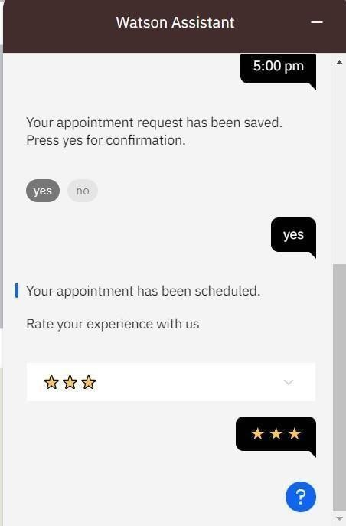

# Question 5:

Create a Watson assistant service with 10 steps and use 3 conditions in it. Load that script in the HTML page.

Script in HTML page:

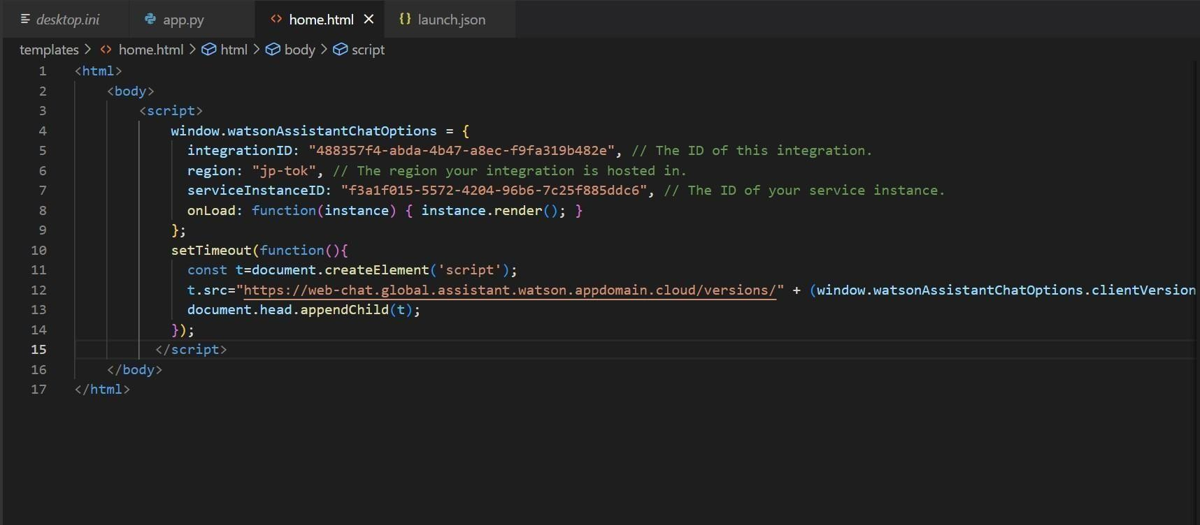

Food-ordering bot:

 

Welcome, how can I assist you?



Select the food item







 

For delivery we yvill need a few pieces of information. Let me guide you through this process!

First, please provide your first name.



Thanks! Now, enter your last name.

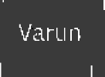

Awesome. I’llatso need an email address associated with your new account. We will send you the delivery details to your email

Which email address would you like to use?

 

Enter the delivery location



We need your iphone number to contact you. Would you like to do so?

Yes, I'd like to add a phone numbers

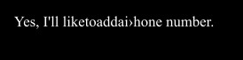

Okay, please enter your phone number below.



 

Please enter a vahd who ne nrim bei.







Thands! Does the folloWing information look correct? If so, I Will proceed a•itI1 placing your order

* Name: Var unArun
* Email Address: ‹zriinvar•maiI.com
* Phone Number:6482973043
  + Delivery Location: 12 th Street Manali

IU WtO W II



 

* Email Address: ai”unvñLLIf1 gn1‹ail.com “
* Phone Number: 6482973043
* Delivery Location: 12 th Street Manali

I1C WtO W II



Your order will be uclivcred within 30 mins! You will receive an cmai I contrmation shortly.

WeSCO 0!